**Final Year B.Tech Project-I Report**

on

**“Sangeet Riyaz"**

for the Degree of

**Bachelor of Technology**

In

**Computer Science and Engineering**

Submitted by

**[2019BTECS00100] Siddharth Mukkanwar**

**[2019BTECS00044] Prathamesh Chavan**

**[2019BTECS00107] Abhishek Bele**

**[2020BTECS00212] Pranita Bhosale**

Under the Guidance of

**Ms. N. L. Mudegol**



**Department of Computer Science and Engineering,**

**Walchand College of Engineering, Sangli.**

(An Autonomous Institute)

**2022-23**



**Walchand College of Engineering, Sangli.**

(An Autonomous Institute)

**Department of Computer Science and Engineering**

**CERTIFICATE**

This is to certify that the Project Report entitled, **"Sangeet Riyaz"** submitted by

**[2019BTECS00100] Siddharth Mukkanwar**

**[2019BTECS00044] Prathamesh Chavan**

**[2019BTECS00078] Abhishek Bele**

**[2020BTECS00212] Pranita Bhosale**

to Walchand College of Engineering, Sangli, India, is a record of bonafide Project work of course **"PROJECT-I”** carried out by him/her under my/our supervision and guidance and is worthy of consideration for the award of the degree of Bachelor of Technology in Computer Science & Engineering during the academic year **2022-23**.

|  |  |  |
| --- | --- | --- |
| **Ms. N. L. Mudegol**  Guide | **Dr. M. A. Shah**  Panel Member | **Ms. S. A. Aitwade**  Panel Member |

|  |
| --- |
| **Dr. M. A. Shah**  Head  Department of Computer Science and Engineering |

**Acknowledgement**

We would like to express our utmost gratitude to our HOD Ma’am as well as **Guide Ms. Mudegol** Ma’am, who guided us all the way through the project. She solved whatever problems we faced and mentored us for a successful project Completion & Implementation of the Project.

**Declaration**

I hereby declare that work presented in this project report titled **"Sangeet Riyaz"** submitted by us in the partial fulfilment of the requirement of the award of the degree of Bachelor of Technology (B.Tech) submitted in the department of Computer Science & Engineering, Walchand College of Engineering, Sangli, is an authentic record of my project work carried out under the guidance of **Ms. N. L. Mudegol** Ma’am.

**[2019BTECS00100] Siddharth Mukkanwar**

**[2019BTECS00044] Prathamesh Chavan**

**[2019BTECS00078] Abhishek Bele**

**[2020BTECS00212] Pranita Bhosale**

Date: 09/12/2022

Place: Sangli.

**Abstract**

In India as well as in the world there are a lot of untrained good singers who wants to improve their singing skills but don’t have a good source. They learn by listening & seeing others. Also there are applications which help to give feedback but they are paid or on PC. So, everyone not get access to it. So, we bring an idea of a mobile application which will give feedback on singing & can be accessed by everyone at free of cost. So, to help teachers & non-professional singers we develop an app will give feedback on their singing that will help teachers to teach their students easily & also Non-professional singers can improves their vocals.

**1. Problem Statement**

To create an application which can gives feedback on Riyaz and also can analyze technical aspects of music.

**2. Introduction**

As the technology is growing day by day, and it’s helping people in their work and life. Technology is also being used in the field of music. Singing professionals make use of technology to improve and better analyze their vocals. So, singing teachers find it difficult to give feedback to their students verbally & also non-professional singers do not have any source to analyze their vocals. So, teachers & also non-professional singers can make use of technology. So, to help teachers & non-professional singers we will make an app which can give feedback on their singing that will help teachers to teach their students easily & also non-professional singers can improves their vocals.

**3. Motivation**

A technology is growing day by day and a multiple online facilities are easily access to everyone. But they are costly, we need to pay for access the softwares. So the multiple applications are available online but they are paid, some are get Vocal Feedback but they are available to work only on PC. So, everyone not get access to it. For to remove this problems we bring an idea of a mobile application which will give feedback on singing & can be access by everyone in free of cost.

**4. Significance**

This will be a very useful application for singing teachers & non-professional singers. Teachers can use this app while teaching to their students So they don’t need any laptop or PC to use this app. Untrained singers can also use this application to analyze their singing & can improves it without any special guidance.

**5. Literature Survey**

**Celemony Melodyne:** In 2008 the German magazine Der Spiegel described Celemony. Melodyne as a photoshop for sound. The Innovative approach to visualize music in Celemony involves representing single sounds such as duraxation, volume and pitch. Unlike Auto-Tune, Celemony is able to process polyphonic sound [5]

**Serato Pitch’N’Time Pro:** Serato Pitch ’N’ Time Pro is a pitch-shifting and time-stretching plug-in for the Pro Tools platform intended to be used by professionals. Pitch’N’Time provides a good quality of pitch shifting and tempo correction which do not affect the timbre

of the recording. It was achieved by using some properties of human perception in the sound processing instead of mathematical operations only. The program is currently widely used in the UK to correct pitch in the films before they are to be transferred into a video version [5]

**6. Objectives**

Following are the objectives of the proposed dissertation work:

1. To study technical aspects of music.
2. To develop an application which can gives feedback on Riyaz.
3. To analyze technical aspects of Music.
4. To help singing teachers and untrained singers to teach students & also analyze & improve pitch accuracy.
5. To record and store the Audio as well as the performance graph.

**7. Methodology**

1. Collected information about musical notes, chords with their frequencies, How the notes are sung while doing Riyaz, How to improvise pitch.

2. For developing the application we used a PSOLA pitch detection algorithm, we use Java to build this application.

3. It includes a pitch monitor which detects real time pitch and shows the frequency of the pitch being sung.

4. It has voice recorder which records the real time voice, the pitch monitor gets activated when the recording is started.

5. When the recording is stop it shows a feedback on overall performance which includes vocal range, pitch over time graph and details like average range, maximum, minimum frequency of voice quality and average pitch.

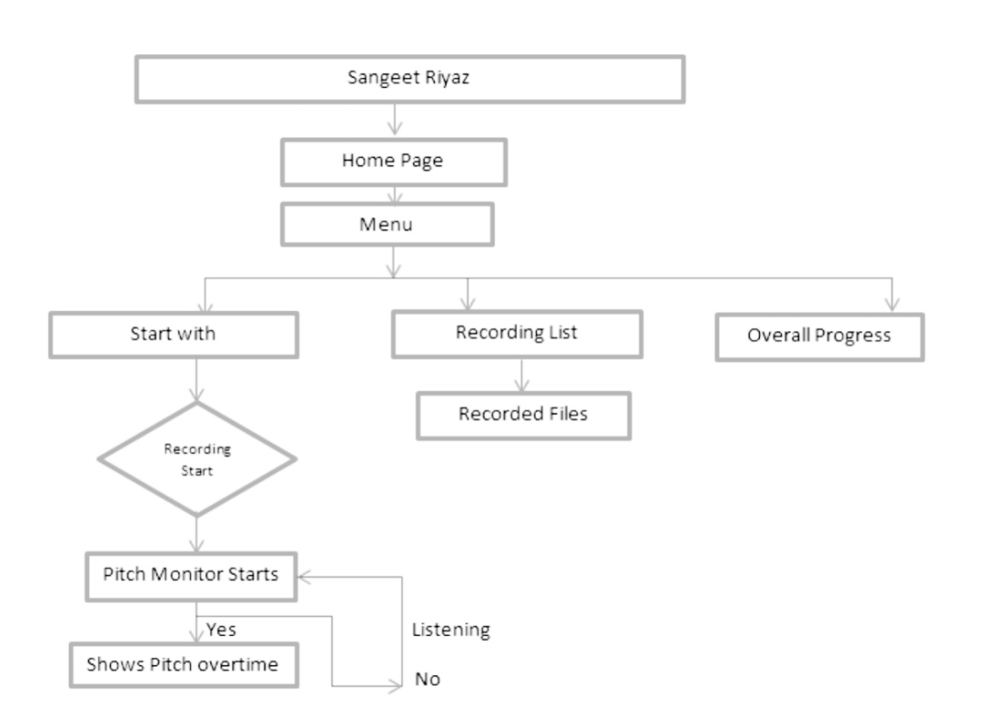

**8. Implementation and results**

* Shows real time graph for vocal frequency of notes being sung:

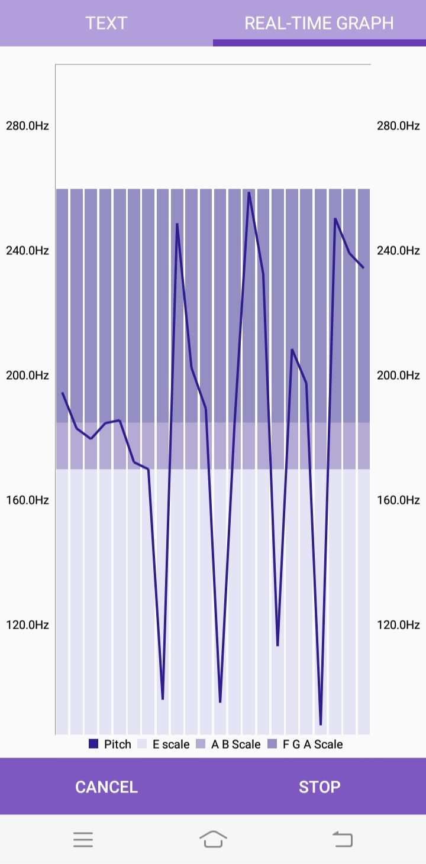

* Shows overview of frequency range:

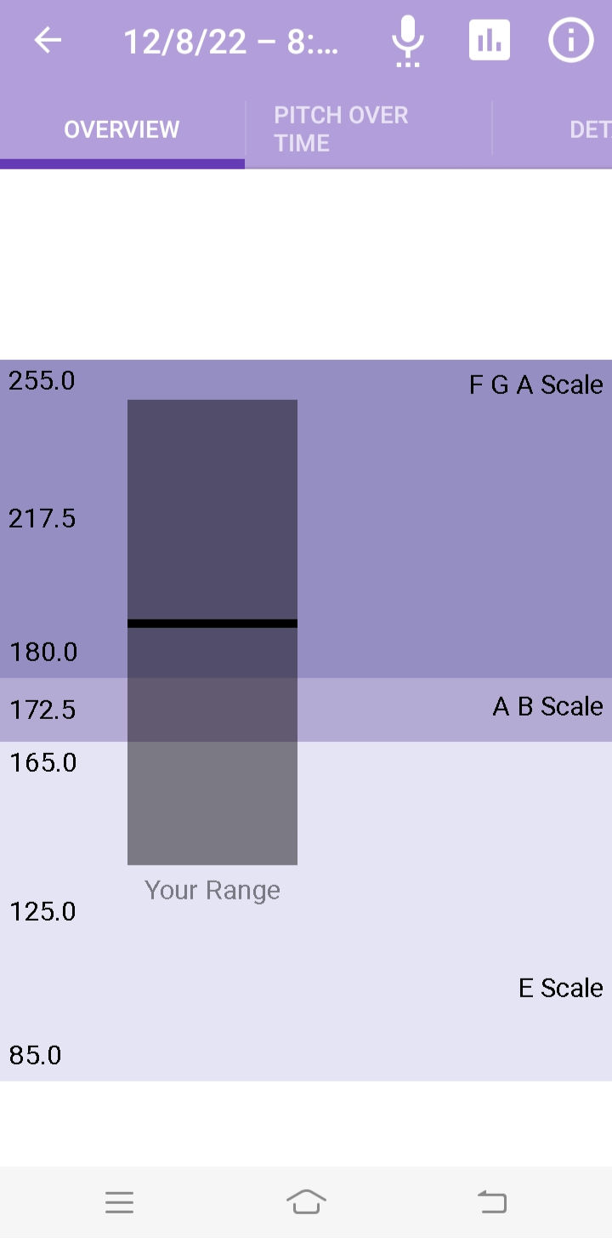

* Shows recording of Audio with date and time:

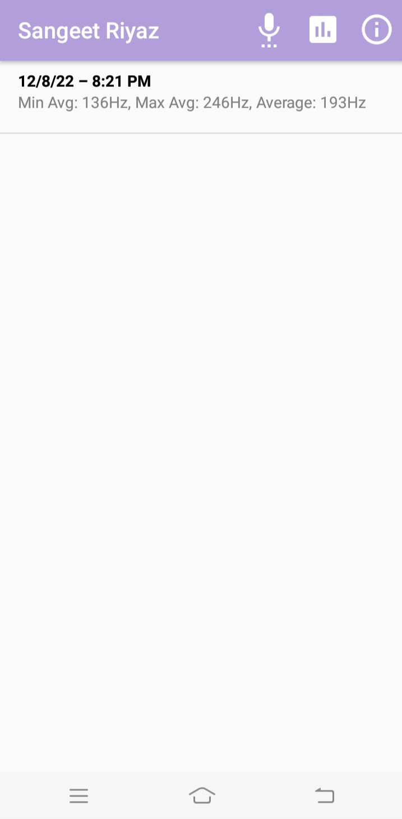

* Shows the performance details of general average, minimum and maximum average with voice quality:

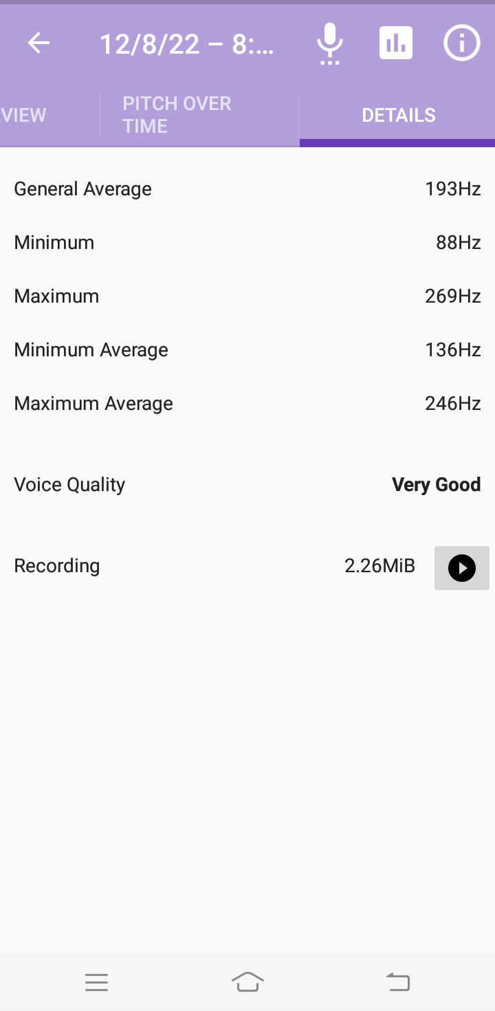

**9. Conclusion**

This will be very useful for Singing Teachers for teaching music to their students by using visuals. It will be easy for Teachers to explain their mistakes and also for students can understand their mistakes for improvement. Untrained Singers can make use of this Application to Analyze & Improves their Singing without any Special Guidance or any Special Resources.

**References**

1. <https://ieeexplore.ieee.org/document/4475948>
2. <http://musicstudies.org/wpcontent/uploads/2017/01/Wilson_JIMS_0821210.pdf>
3. <https://ses.library.usyd.edu.au/handle/2123/1526>
4. <https://ieeexplore.ieee.org/stamp/stamp.jsp?tp=&arnumber=9829265>
5. <https://www.researchgate.net/publication/297617925_Application_for_the_Automatic_Pitch_Detection_and_Correction_of_Detuned_Singing>

**Annexure**

1. Publications / patents if any
2. Participation in competitions/ hackathon etc